1. **Rate Request Form :**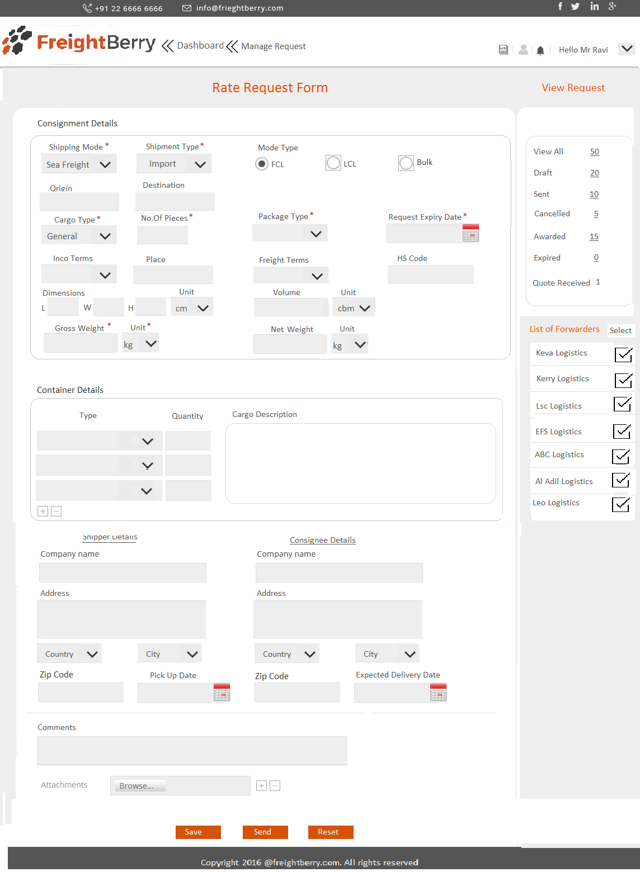
2. Client : Manage Request: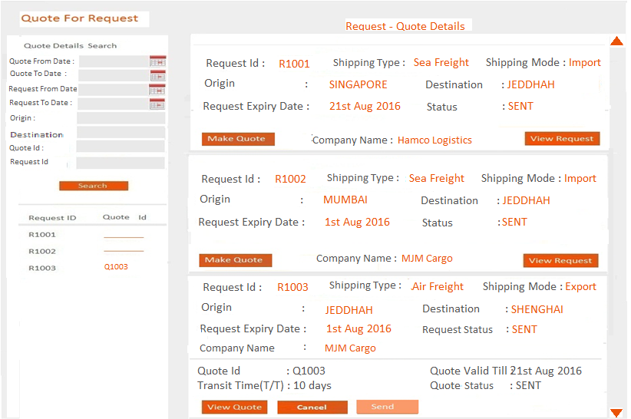
3. Agent: Dashboard : View Rate Requests: 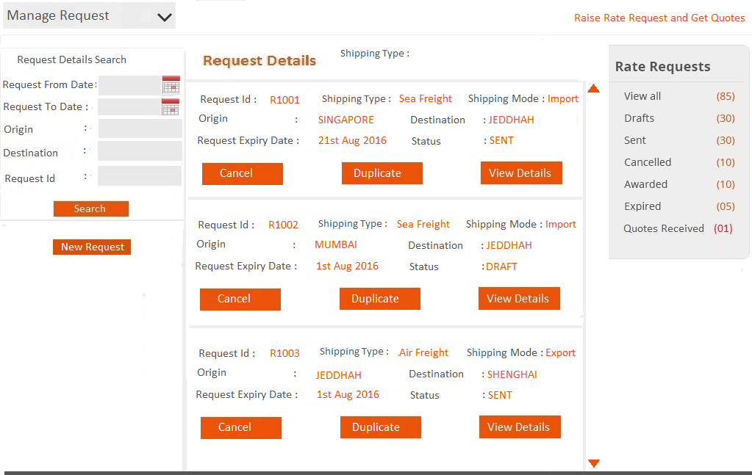
4. Forwarder : View Rate Request:

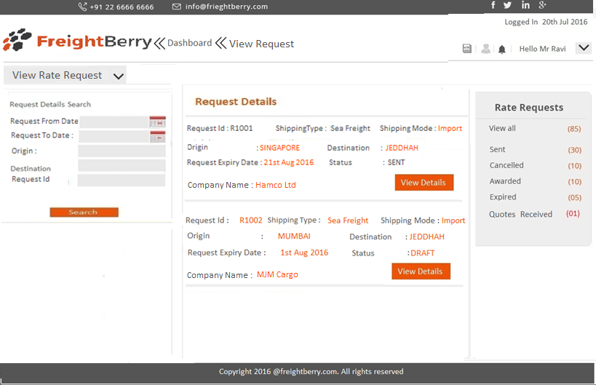

1. Forwarder/Agent Make Quote: Quote Form:

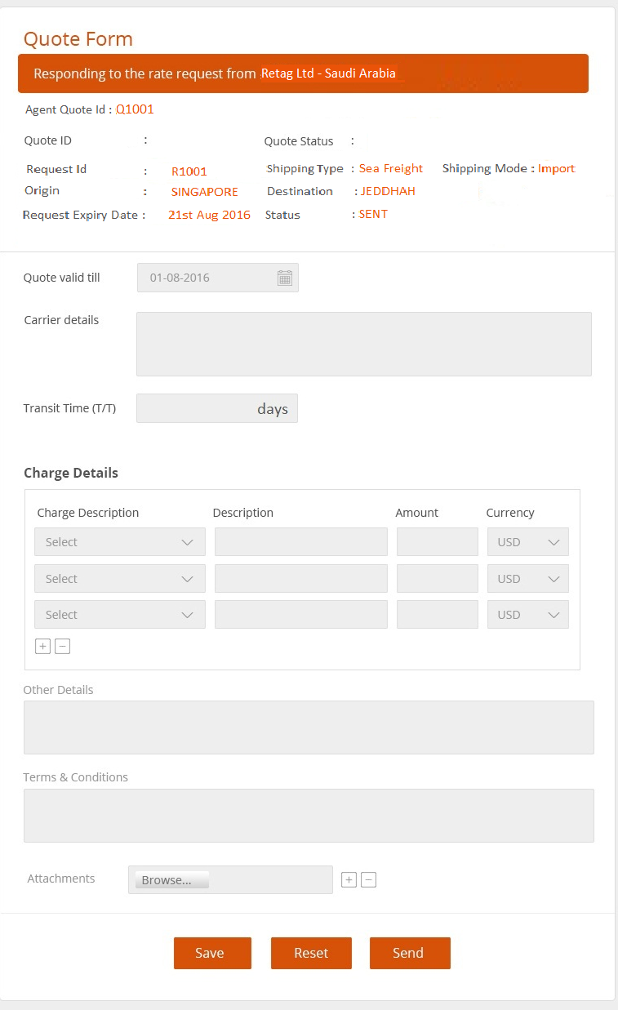

1. Forwarder View Agent Quotes: 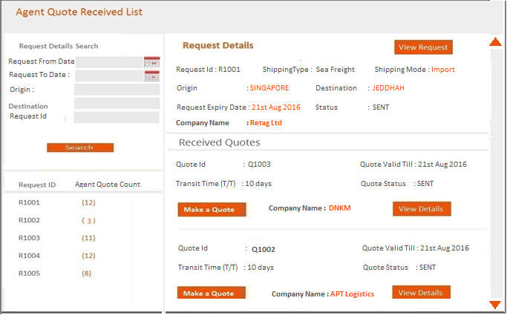
2. Forwarder: Manage Quote : Final Quote created by Forwarder/Agent “My Quotes”:

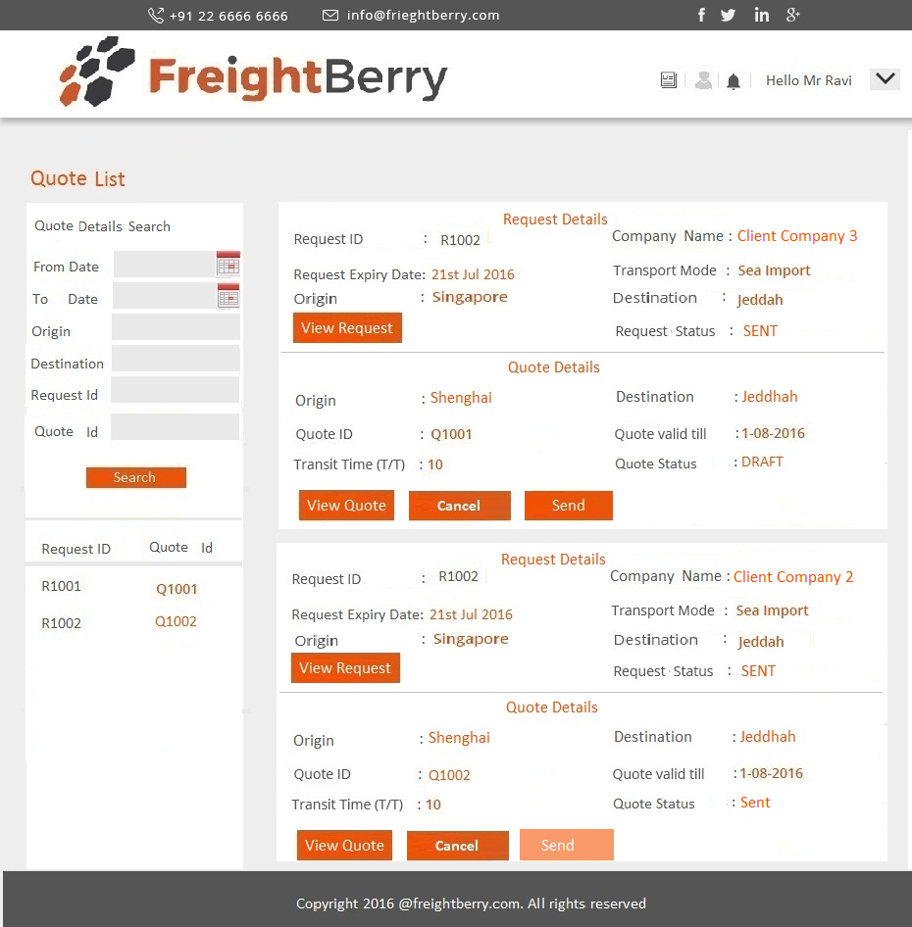

1. Quotes Received by Client From Forwarder:

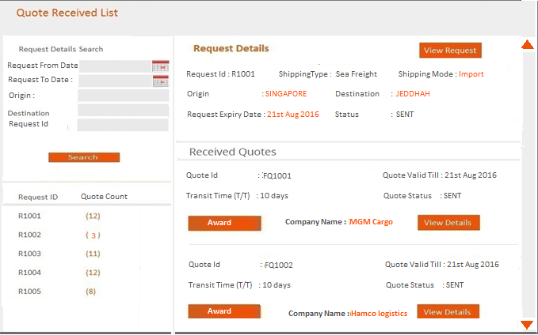

1. Client Dashboard:

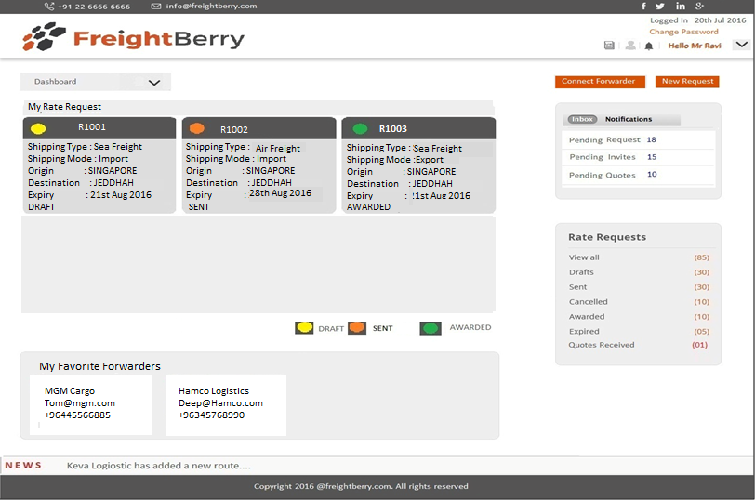

1. Freight Forwarder / Agent Dashboard:

